**225/2**

**ISLAMIC RELIGIOUS**

**EDUCATION**

(Beliefs and Practices of Islam)

**Paper 2**

**Jul/Aug 2016**

**2 ½ Hours**

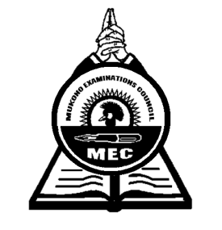

**MUKONO EXAMINATIONS COUNCIL**

**Uganda Certificate of Education**

**ISLAMIC RELIGIOUS EDUCATION**

(Beliefs and Practices of Islam)

Paper 2

**2 Hours 30 Minutes**

**INSTRUCTIONS TO CANDIDATES**

* *Answer* ***three*** *questions choosing* ***ONE*** *from each section.*

**SECTION A**

1. a) Explain when a Muslim should totally purify him / herself.

b) Describe the process of total purification.

1. a) Show how a Muslim should conduct prayer for the dead.

b) Of what relevance is the prayer for the dead? (Swalat Al- Janaz)

1. a) Outline the Sunna days of fasting in Islam.

b) Who is at liberty to eat during day in the month of Ramadhan?

1. a) How is the muslim marriage ceremony conducted?

b) Show how muslims have deviated from it?

**SECTION B**

1. a) Explain the types of worship (Ibadat)

b) What do muslims gain from worshipping Allan?

1. What miracles did the following prophets have;
2. Ibrahim
3. Isah
4. a) What are the Islamic teachings on Allah’s books?

b) What is the difference between the Qur’an and other books?

1. Identify the names of the day of judgment with their meaning?

**SECTION C**

1. a) How does Islam promote cleanliness of one’s body?

b) What makes some muslims not to follow the Islamic prescriptions on cleanliness?

1. As a moslem, what social obligations do you have on the following?
2. Relatives
3. Servants
4. a) Why is sexual harassment on the increase in Uganda?

b) What steps did Islam put up to control it?

1. Describe what Islam teaches about
2. Truthfulness
3. Generosity

***End -***